FAMAX QC SYSTEM – IT ADMIN EDITION
- For IT Admin, if the system down then you must reactivate it. So the first step is remote into server 192.168.0.5.
- Then open DOCKER DESKTOP.
- After that at “Container” Menu, make sure the application is running if not you can click the play button at the action column.
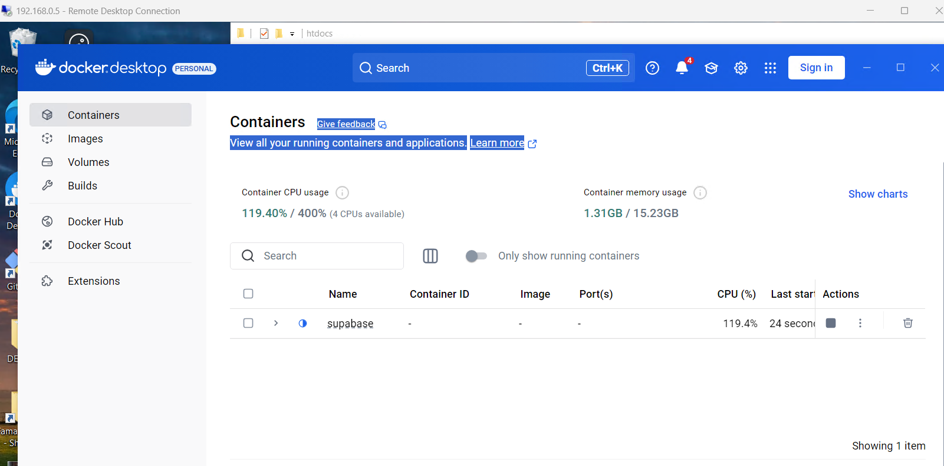
- Also then click on the word “Supabase” as rounded on the image above.
- Some of the Supabase functionality might have not started properly, so click start button on by one to start it. It might take some time. For example image below show a function is not start properly. Then click the start button.
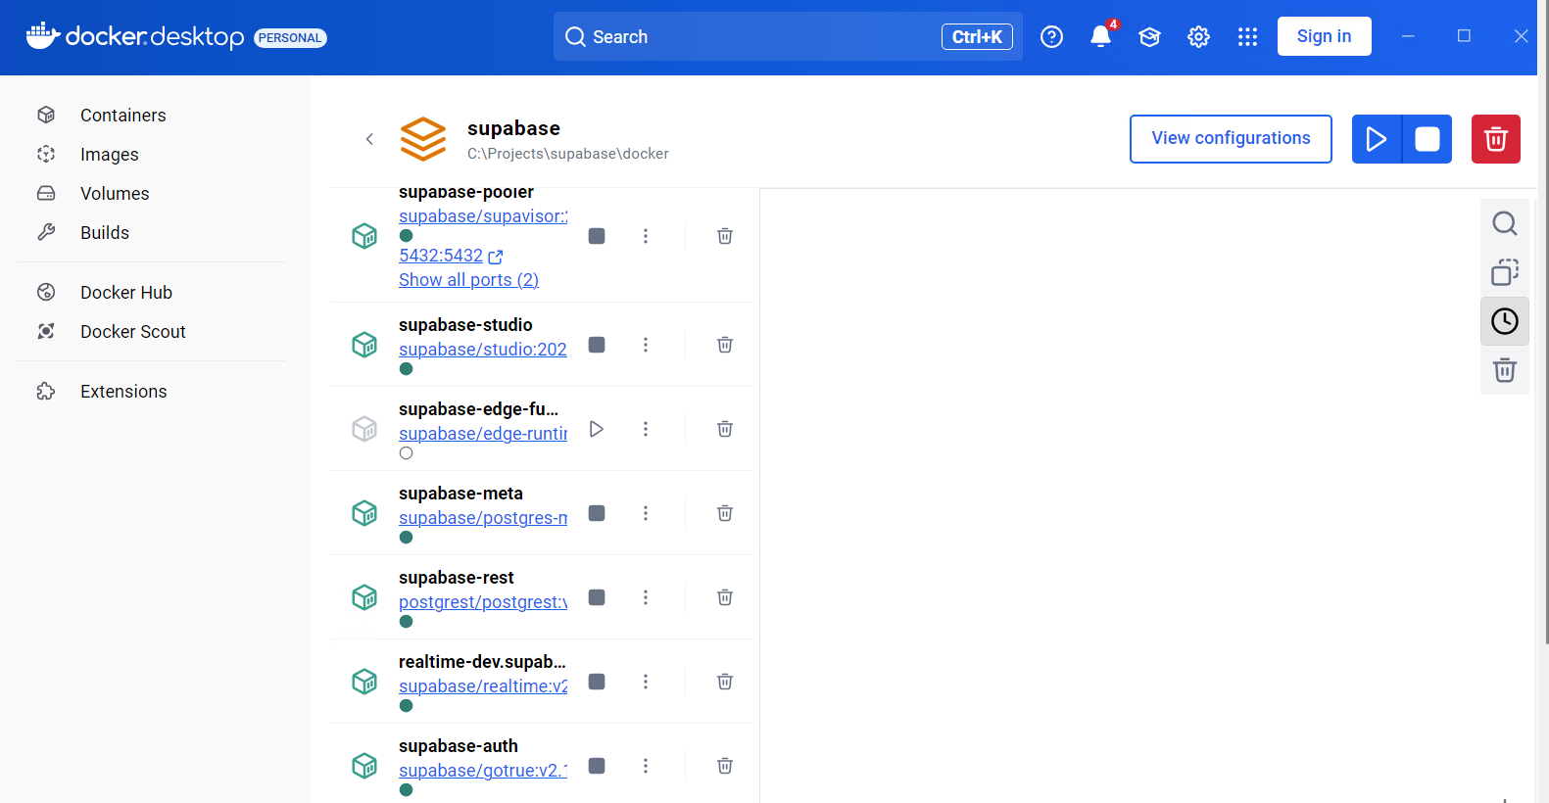

- Wait until all started the open the command prompt.
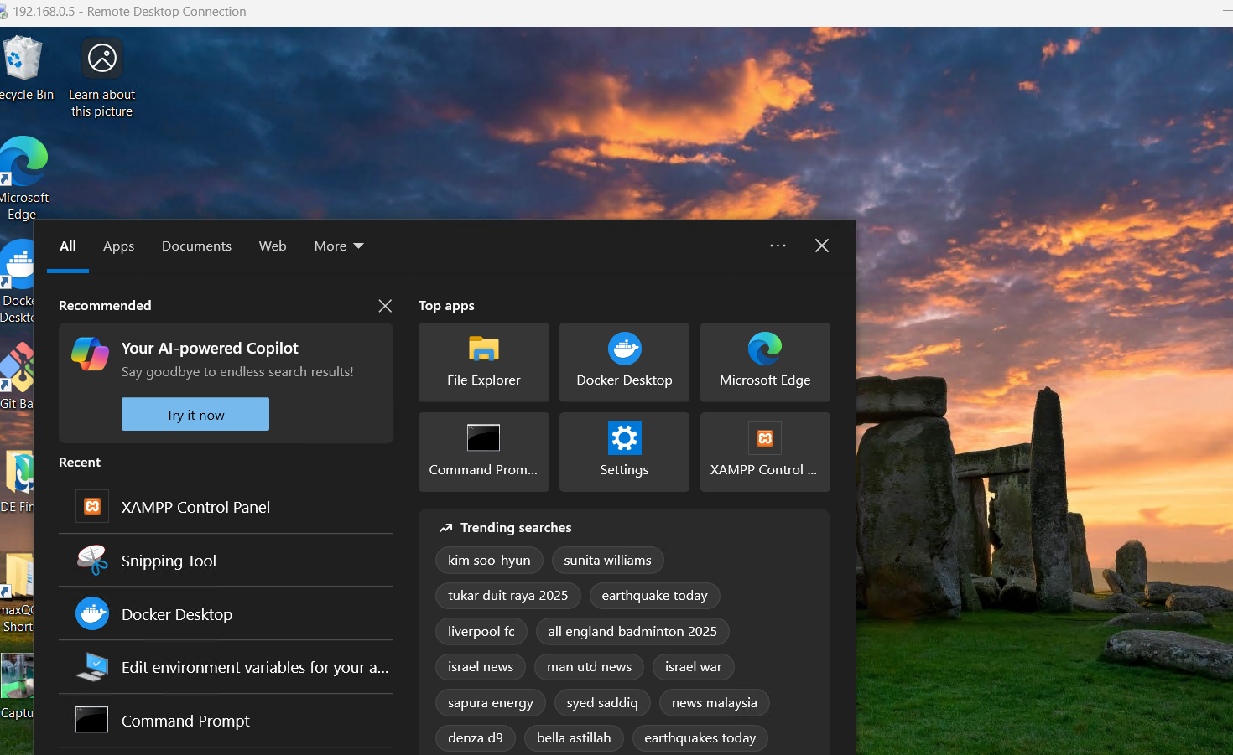

- Then run command : cd C:\Users\Acer\IPQC_Project\FamaxQCSystem
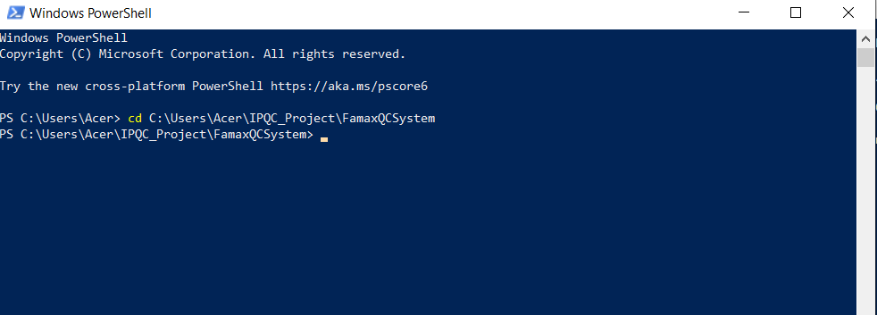

- Then run this code: node server.js
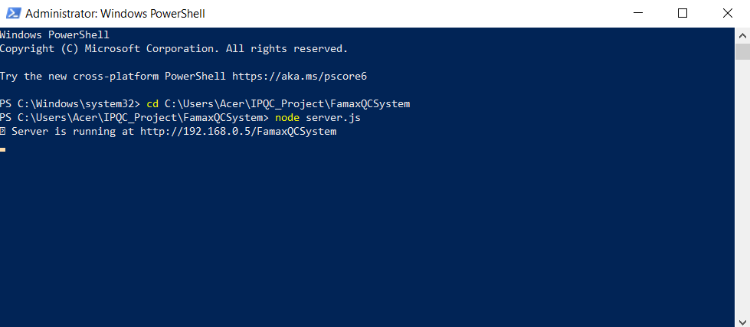

- Now you can try access http://192.168.0.5/FamaxQCSystem/ .

